Writing Purpose: Inform and Explain

Informing gives objective factual information. Explaining gives reasons for how or why something happens. The best writing both informs and explains.
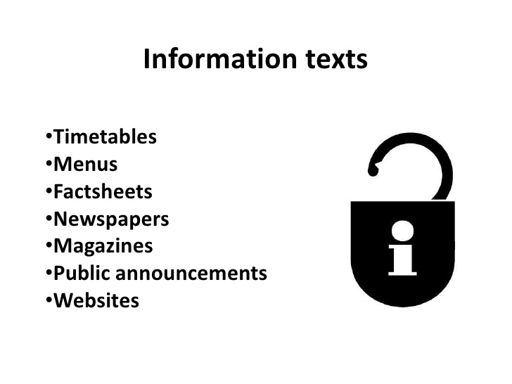 | 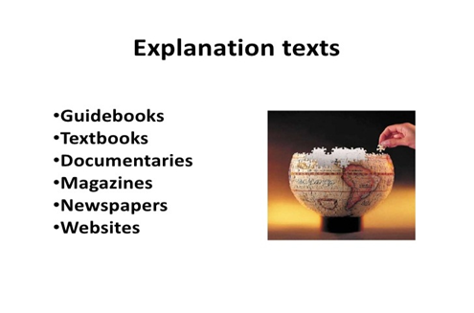

Structure  - Logical order  - Brief, focused paragraphs  - Content is often general to specific  - Clear links between paragraphs  - Headings and subheadings  - Imagery and Graphics  - Use short and clear sentences | Writing features  - Convey essential information  - Straightforward language  - Factual and impersonal  - Clear, concise language  - Give a balanced view with evidence for any points made  - New terms are explained and defined

Task: Write an informative/explanatory paper based on a focused topic of your choice.
- Two pages, typed, double spaced, MLA format
- Work Cited page with two sources of information (one must be a database)
Learning topic (Your general topic):________________________________________________________________________
Focus your writing on something specific. Possible subtopics for Inform and Explain:

Write a complete sentence detailing what you intend to inform and explain to your audience:
________________________________________________________________________________________________________________________

Inform and Explain example:

Wrigley Rolls Out Alert Energy Caffeinated Chewing Gum Line
CHICAGO -- One of the world's largest chewing gum companies will take the wraps off Alert Energy gum next month. Each piece of new chewing gum has about half the caffeine content of a cup of coffee: 40 mg., approximately half the amount provided by a small (6 fl.oz.) coffee serving.
Wm. Wrigley Jr. Co., a subsidiary of Mars, is marketing its new Alert Energy Caffeine Gum as an adult gum, and an "energy solution that gives consumers the power to control how much caffeine they get," the company explained.
Alert Energy will be sold in packages of eight fruit- or mint-flavored pieces, retailing for about $2.99. The company said it will sell the gum in select markets, starting in April.
Wrigley says the product is not recommended for children or people sensitive to caffeine.

